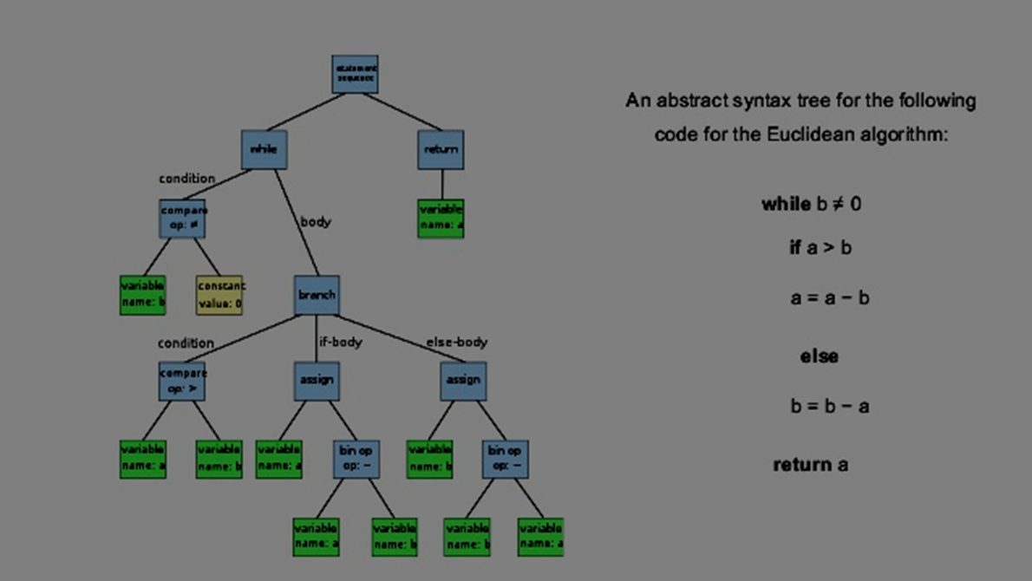

Syntax Trees in Compilers

CO322

E/13/244 E/13/377 E/13/132  | May 12, 2017

An abstract syntax tree is a [tree](https://en.wikipedia.org/wiki/Directed_tree) representation of the [abstract syntactic](https://en.wikipedia.org/wiki/Abstract_syntax) structure of [source code](https://en.wikipedia.org/wiki/Source_code) written in a [programming language](https://en.wikipedia.org/wiki/Programming_language). Each node of the tree denotes a construct occurring in the source code. The syntax is "abstract" in not representing every detail appearing in the real syntax. For instance, grouping [parentheses](https://en.wikipedia.org/wiki/Bracket#Parentheses) are implicit in the tree structure, and a syntactic construct like an if-condition-then expression may be denoted by means of a single node with three branches.

This abstract syntax trees from concrete syntax trees, traditionally designated [parse trees](https://en.wikipedia.org/wiki/Parse_tree), which are often built by a [parser](https://en.wikipedia.org/wiki/Parser) during the source code translation and [compiling](https://en.wikipedia.org/wiki/Compiler) process. Once built, additional information is added to the abstract syntax tree by means of subsequent processing.

# Design

This is way to convert a code into a syntax tree. We can use a simple code for to do this.

e.g:1

while b != 0

if a > b

a = a – b;

else

b = b-a;

return a;

When this is converted into a tree it is like this.

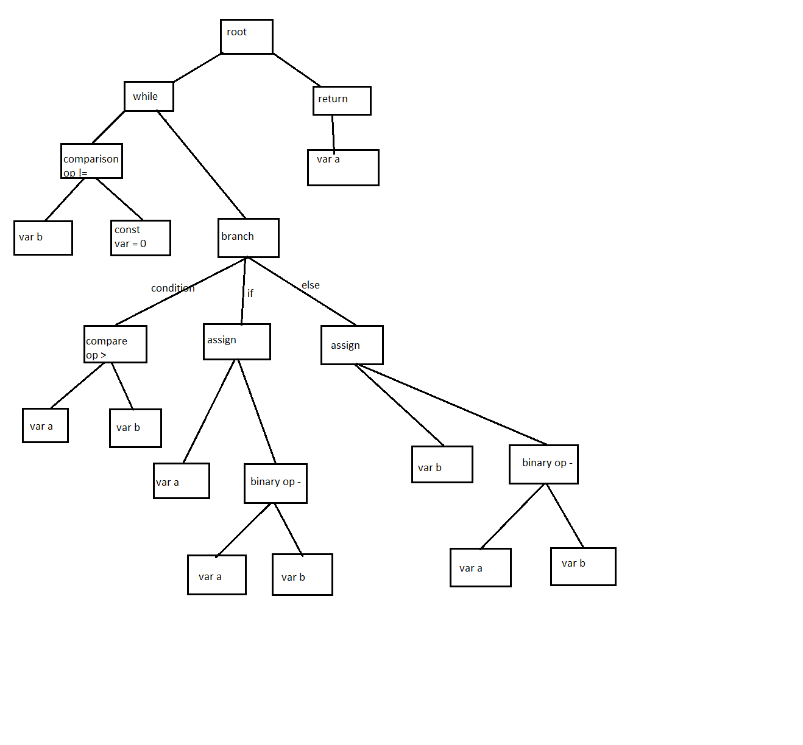

### 

### e.g. 2:

If a > b:

c = c + d;

else

c = c – d;

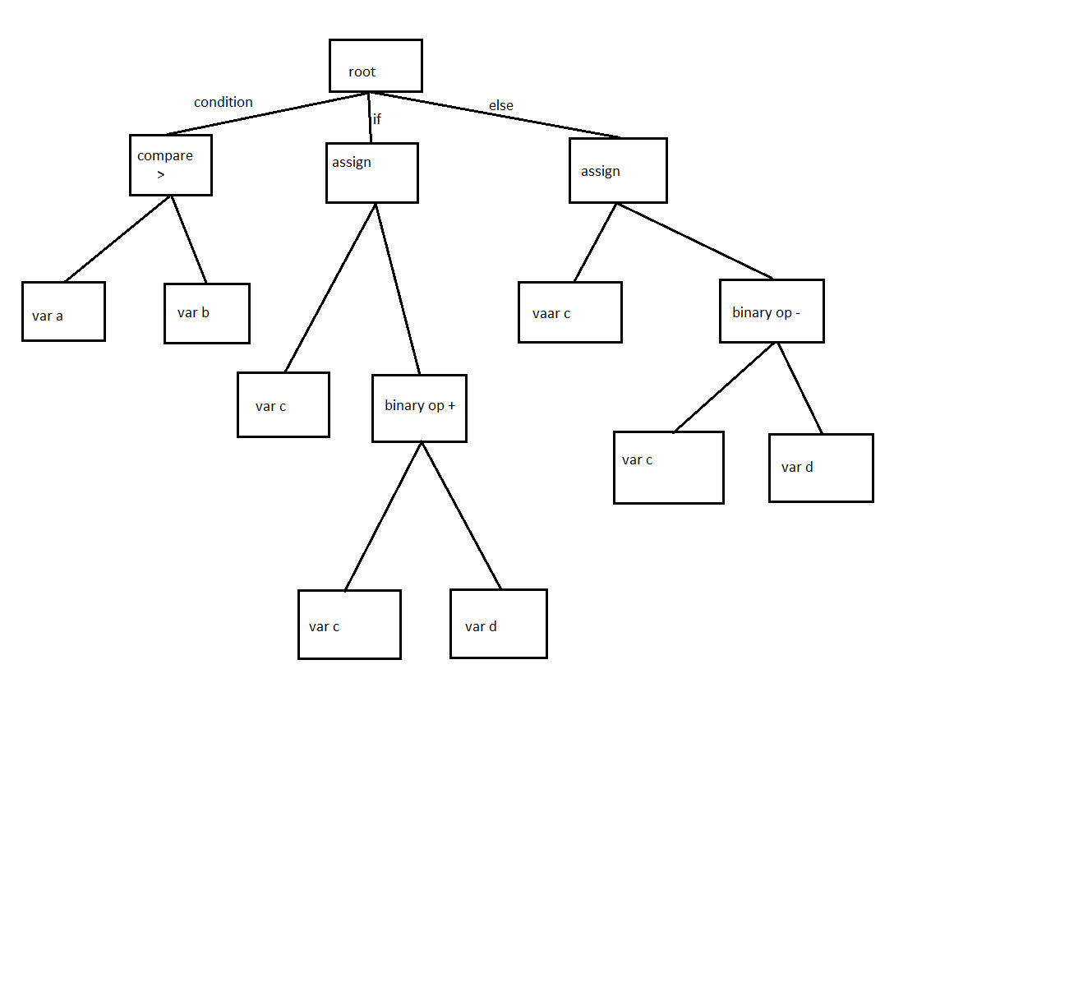

e.g: 3

c = 0

while c < 10

print c ;

c = c + 1;

